Thousandshores Deutschland GmbH
EU Declaration of Conformity

We
Manufacturer’s Name: Thousandshores Deutschland GmbH
Manufacturer’s Address: Bredowstraße, 17, Hamburg, 22113, DE

Hereby declares that the product:
Trademark: OxyLED
Model NO. : BW-E27-3(25-800)
Model NO. (of supplier): BW-E27-3(25-800)
Is fully in conformity with the essential requirements of the following EU Directive or other normative documents. This declaration is based on the full compliance of the products with the following European standards:
Directive | Standard detail and/or measurement reference
EMC Directive 2014/30/EU | EN 55015:2013/A1:2015  EN 61547:2009  EN61000-3-2:2014  EN61000-3-3:2013
EMC Directive 2014/35/EU | EN 60598-1:2015+A1:2018  EN 60598-2-20:2015
RoHS Directive 2011/65/EU | IEC 62321-4:2013+AMD1:2017  IEC 62321-5:2013  IEC 62321-6:2015  IEC 62321-7-1:2015, IEC 62321-7-2:2017  IEC 62321-8:2017

By Manufacturer:
Thousandshores Deutschland GmbH

AUTHORISED SIGNATURE:

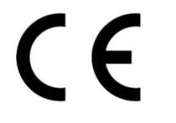
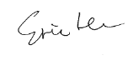

Name: Eric He
Division and Position: CEO
Place and date of issue: Shenzhen 2019/10/25

